1.0 INTRODUCTION

The Society of Automotive Engineers Collegiate Design Series was created to enable students to apply the knowledge obtained in the classroom to real world problems. The Aero Design Competition requires teams to design, build, and fly aircraft, given specific design constraints. For the 2005 competition, these constraints include a maximum take-off distance of 200 ft, a maximum wingspan of 5 ft, a maximum landing distance of 400 ft, and the requirement to contain a 5" x 6" x 8" payload bay. In addition, the aircraft must use an OS 0.61 FX engine, with an E-4010 muffler, fueled with 10% nitro-methane fuel; also, the propeller must rotate at the same speed as the engine crankshaft. The main objective is to lift the most weight possible, following these constraints.
To accomplish the multifaceted task of creating an aircraft to meet these design criteria, the Aerocats design team from the University of Cincinnati (UC) was divided into several groups, each with specific responsibilities. The layout group produced technical drawings to aid in construction, while the aerodynamics group focused upon the wing configuration, airfoil selection, and estimation of relevant parameters. The structures, weight, and balance group performed all structural analysis including load path design and structural strength calculations, as well as the placement of components to achieve a proper center of gravity location. Engine testing was conducted by the propulsion group, essentially to determine the optimal propeller. The stability and controls group calculated the aircraft’s stability characteristics and constructed a control system to satisfy the mission criteria. Finally, the performance and optimization group calculated performance qualities, which were used to determine an optimal configuration. The results of each group are discussed in the following sections.

2.0 LAYOUT SUMMARY

The final design to be used in the competition may be viewed in graphical form in the Drawings section, following the discussion of the design evolution and analyses. In brief, the aircraft may be characterized as follows. Most significantly, a box-wing configuration was utilized, in order to minimize the induced drag. The remainder of the design consisted of a traditional tail and fuselage, tricycle landing gear, and standard aerodynamic control surfaces.
3.0 AERODYNAMICS & WING CONFIGURATION
Prior to initiating other aspects of the design process, an assessment of aerodynamic concerns was crucial in determining the preliminary design, specifically in terms of the wing configuration. For this purpose, aerodynamic analyses were conducted using TORNADO, a code based upon vortex lattice theory. Concurrently, a variety of airfoils were investigated using XFOIL, which provided two-dimensional airfoil data. Thereafter, a variety of design parameters were varied and studied through a series of models in TORNADO, ultimately providing the final wing configuration.

3.1 Initial Configuration

At the onset of the design process, a number of options were considered, among which were a conventional monoplane, a traditional biplane, and a variety of high-efficiency designs such as the C-wing and the box-wing; these configurations are illustrated in Figure 3.1. Due to the limitation upon wingspan, coupled with the goal of producing high lift, one of the primary concerns was to optimize the Oswald efficiency factor (e). By reviewing the theoretical results of Kroo¹, among others, the box-wing was determined to be the optimum configuration, taking into consideration both e (as noted in Figure 1, for an example height-to-span ratio of 0.2) and also the increased lifting surface area provided by two main wings. Subsequent results from TORNADO corroborated the referenced theory.
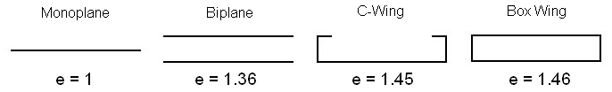
Figure 3.1: Investigated Wing Configurations

3.2 Airfoil Selection
Using both XFOIL and TORNADO as analytical tools, a variety of airfoils were investigated for each of the components. Several high-lift, low Reynolds-number airfoils were evaluated for use as the main wings, but the majority of these were deemed impractical in terms of construction, typically due to
Reference (1): Kroo et al, “Highly Non-Planar Lifting Systems.” Originally a presentation at “Transporation beyond 2000: Technologies Needed for Engineering Design.” NASA Langley Research Center, Sept. 26-28, 1995.
a combination of high camber and a relatively thin rear portion (e.g. the Selig S1223). Furthermore, airfoils of this type produced relatively high moments, and were therefore a concern in terms of stability.
Finally, the Eppler E423 was selected (see Figure 3.2). This airfoil was deemed appropriate for the high-lift, low Reynolds number application, and also satisfied the concerns of practicality in terms of construction. Decambering the airfoil by 25% provided sufficient lift, while shifting the drag bucket to lower angles of attack, thereby producing an improved drag polar with a higher lift-to-drag ratio (L/D). This modification also reduced the pitching moment, and produced a more linear lift slope curve. The maximum C_{l} of this airfoil is 1.8 at a 12º angle of attack; due to the large camber, it also provides positive lift at negative angles of attack, down to -8º. Published experimental data were used to characterize the E423; independent wind-tunnel testing, done by the Aerocats team at UC, validated the reference data and authenticated the airfoil construction – further details are provided in Section 7.
For the winglets, the NACA 4412 (shown in Figure 3.4) provided the ideal amount of lift at the root of the winglet, such that the lift distribution from main wing tip to winglet root is optimized. This NACA 4412 then transitions into a symmetrical NACA 0020 at the winglet’s tip (Figure 3.5), making for smooth connection surfaces. Both the horizontal and vertical tails are NACA 0014 airfoils (Figure 3.3), whose symmetry and wide drag bucket will aid in aircraft stability. Note that the figures below merely indicate the airfoil contours, and are not scaled according to their use on the aircraft.

Figure 3.2: Eppler E423 Figure 3.3: NACA 0014, Horizontal
Main Wing Airfoil & Vertical Tail Airfoil
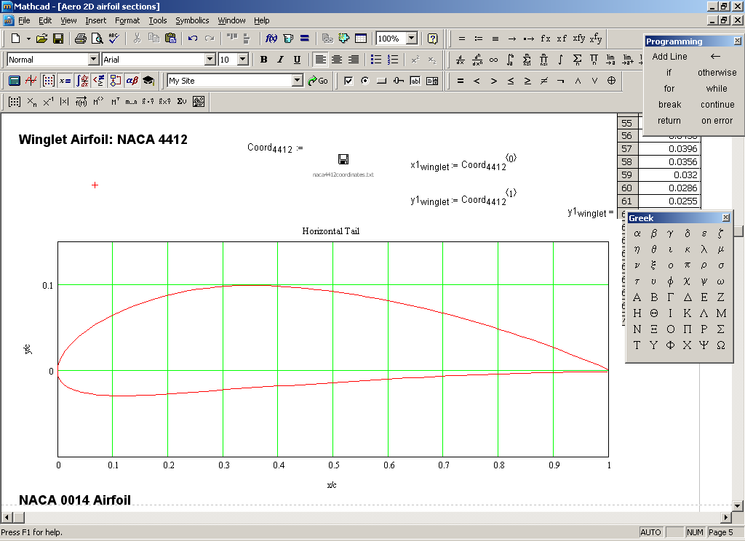

Figure 3.4: NACA 4412 Figure 3.5: NACA 0020
Winglet Airfoil at Wingtips Winglet Airfoil at Midpoint

3.3 Wing Configuration Refinement

Optimization of the design was accomplished using TORNADO. In order to provide easy access to the payload bay, forward-staggered main wings were analyzed – that is, the top wing was placed slightly ahead of the bottom wing. A 1-foot stagger was found to provide adequate access without incurring significant penalties in lift, drag, or efficiency. Also, a trade study was used to determine the gap-to-span ratio. In theory, an infinite gap would produce the maximum efficiency, but other considerations (e.g. stability and weight issues) limited the gap-to-span ratio to 0.6.
Wing taper was also analyzed, in an attempt to further improve the efficiency factor. However, main wing taper was not employed, because it would induce stalling at the control surfaces (as shown in TORNADO analyses). Moreover, tapered wings would require more complex construction, and provided relatively little increase in the efficiency factor, e.g. about 2% for a taper ratio of 0.7.
However, tapering the winglets was found to be very beneficial. This provided for a more efficient loading over the winglet, and also decreased the side area of the aircraft, thereby improving lateral stability. A trade study was conducted which determined that a winglet root chord of 1.17 feet allowed for the optimum aircraft side area without impact to wing efficiency, lift, and drag. An additional positive aspect of winglet reduction was the decrease in weight. As a further improvement to stability, the winglet’s leading edge was moved aft along the main wings, such that the winglet and main wing trailing edges meet. In figures 3.6 and 3.7, the evolution of the design may be seen in the form of two TORNADO models.

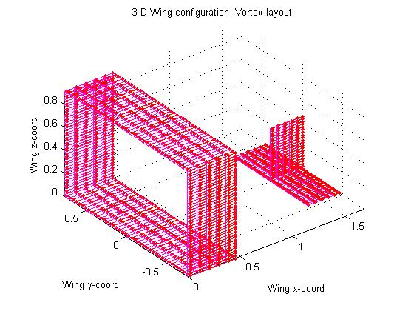
Figure 3.6: Early Box-Wing Model Figure 3.7: Final Airfoil Configuration
(Simple Schematic) (Pressure Distribution)

3.4 Total Aircraft Aerodynamics

After determining the final aircraft configuration, a series of parametric models were developed in Mathcad, which provided the necessary aerodynamic characterization of the total aircraft. Notably, these models were modified according to results from the control surface design, as well as the optimization of aircraft size (both of which will be discussed subsequently). Below, critical aerodynamic data such as the drag polar, drag build-up, and L/D are displayed in the following figures.
Figure 3.8 illustrates the drag polar for the box wing, excluding the other aircraft components; it clearly indicates stall points for both positive and negative angles of attack, by sharp increases in total drag. The decreased camber of the E423mod_0.75Cmb airfoil allows for a gradual stall at both positive and negative angles of attack. As one would expect, the induced drag increases as lift increases.
Drag’s variation with angle of attack is illustrated in Figure 3.9, which displays the contribution of each portion of the aircraft to the total drag. It is important to note that the slight increase in drag just below a zero degree angle of attack is due to the high camber of the E423, which begins to stall on its lower surface at this small range of negative angles of attack. Both Figures 3.10 & 3.11 demonstrate the benefit of using the box-wing, especially the reduction in induced drag, providing a wide L/D curve (and giving a wide range of reliable aircraft operation).
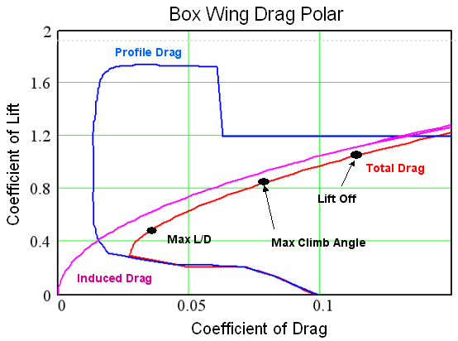
Figure 3.8: Main Wing Drag Polar – Comparison of Induced and Profile Drag

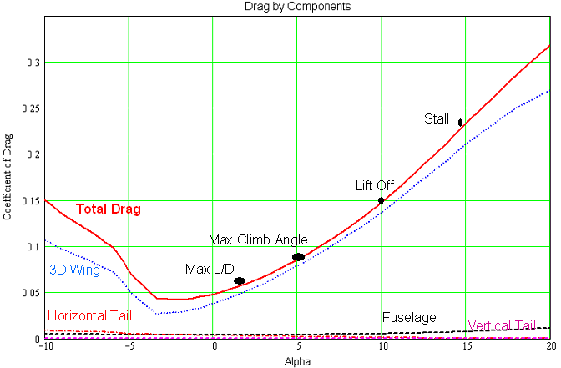
Figure 3.9: Drag Build-up by Components
(Coefficient of Drag vs. Angle of Attack)

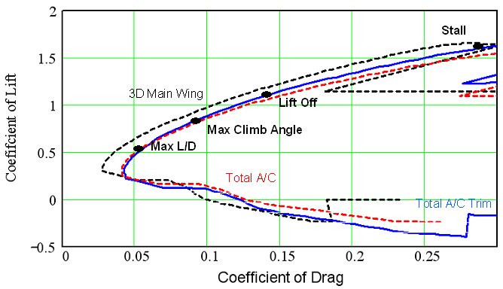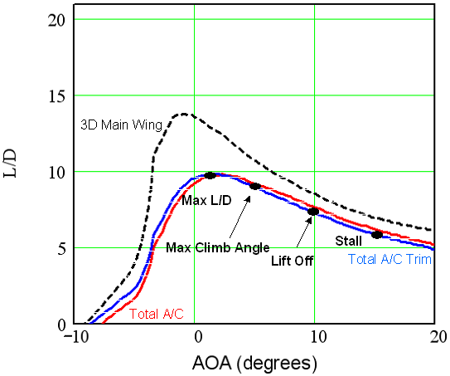
Figure 3.10: Drag Polar (Lift vs. Drag) Figure 3.11: Lift-to-Drag vs. Angle of Attack

4.0 STRUCTURES, WEIGHTS, & BALANCE
The essential purpose of the Structures group was to build the lightest possible plane that would be strong enough to survive the loads and conditions encountered during the mission. The structural design underwent continual iterative modification, due to both theoretical considerations and practicalities that were encountered during the construction. Composite materials were chosen primarily due to their high strength-to-weight. However, materials created many new challenges because they required the use of relatively new construction methods, in comparison to prior UC competition aircraft. Concurrently, theoretical analyses assured that the design would meet the necessary requirements, as described below.
4.1 Structural Design and Fabrication
    - Wing Design
The iterative design process was most evident in the construction of the wings and the control surfaces. A preliminary plan was to use solid foam core construction, with a fiberglass exterior; however, this design was deemed unacceptably heavy. Thereafter, a spanwise central spar was adopted. Graphlite © carbon rods were utilized as spar caps, to bear the maximum loading in the wing structure, supported by a fiberglass shear web.
The second design was so successful that throughout the foam portion of the wing, aft of the spar, was replaced by thin balsa wood ribs covered with monocote. Thus, only a forward D-section of fiberglass-encased foam remained. However, this stage of the design did not take full advantage of the strength provided by the carbon-fiber spar construction, and the solid foam D-section retained excess weight. Subsequently, further refinement led to hollow, semi-monocoque construction throughout, disposing of all foam except for a strip down the length of the spar, used to aid in construction. The resulting front D-section was a fiberglass skin only supported by the balsa ribs. Ultimately, this final design resulted in a weight savings of 75% over the initial solid-foam design. In addition to the main wings, the semi-monocoque construction method was adopted for the tail airfoils and control surfaces.
Load, shear, and moment through the main wing were analyzed. The critical design condition was adopted as a 4-g maneuver with a factor of safety of 1.5 – thus, with a design weight of 32 lbs, the critical load became 192 lbs, evenly split between the two main wings. The analysis was greatly simplified by modeling both wings as cantilever beams, with an added shear force applied at the tips due to the winglets transferring force between the two. Normalized load properties for a wing semi-span appear below in Figure 4.1. According to the analysis, the carbon rod spar caps can withstand compressive and tensile loads of approximately 2270 lb, but the maximum spar cap loading is only +/- 270 lb. Similar analysis was performed on the winglets, indicating much lower forces. Hence, the composite spar construction was deemed more than adequate.
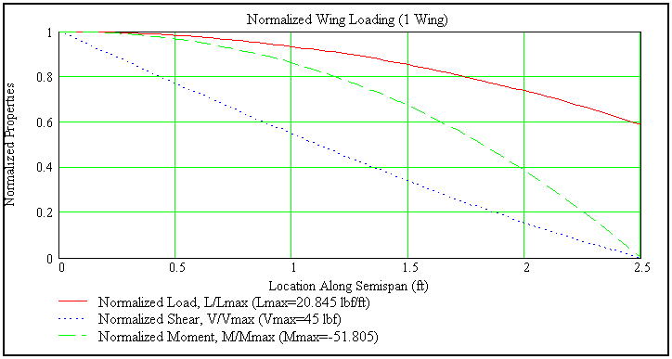
Figure 4.1: Normalized Wing Loading

4.1.2 Fuselage Design
After the successful fabrication of airfoil sections using composites, similar techniques were applied to the fuselage construction. First, a full-scale model of the fuselage was built from solid foam, to be used as a mold. A double layer of fiberglass skin was then formed upon this positive mold, using a coat of Teflon paper to assure that the completed skin would not stick to the mold. The fuselage was formed in two halves, divided lengthwise, using this method. Graphlite © carbon rod stringers were inserted between the two layers of fiberglass, for longitudinal integrity, and carbon-fiber bulkheads provided lateral integrity as well as high-strength attachment points. The completed halves were joined along interior flanges, creating a smooth outer surface.
4.1.3 Connection points
The structural design concern that posed the greatest difficulty was to properly engineer the connection points. To ensure a strong and stable airplane, all connection points had to be designed with consideration of load paths as well as the integrity of each specific joint. This was relatively simple for the fuselage, because the bulkheads provided natural connection points in the design. Both the landing gear and the wings were arranged to minimize the length of the load paths to the payload section.
The design of the winglet connections proved to be particularly difficult due to the angles and load paths inherent in a box-wing construction. The chosen configuration is shown below in Figure 4.2. While the bulk of the loads passing through the winglet are in the vertical direction, the connection members will be in a horizontal direction. In fact, the main wing spars continue outward to join the winglet spars directly, creating a versatile, dependable attachment.
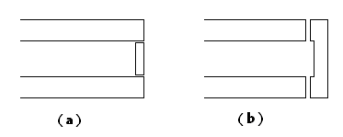
Figure 4.2: Winglet Attachment
(a) Inferior Method (b) Selected Method

    - Landing Gear Design

For the main landing gear struts, extruded carbon fiber rods were chosen as the construction material due to their inherently high strength-to-weight ratio. These struts were manufactured by building up layers of carbon fiber rods (each measuring 0.177in x 0.057in) until the desired strength was obtained. Attachment to the main bulkhead was achieved by the means of a carbon fiber tube, bonded directly to the bulkhead. Curved metal tubes were used as axles for the 4-inch diameter aluminum wheels. A more traditional spring steel strut was used for the front landing gear, combined with the same type of wheel. Both theoretical and experimental analyses were performed, to determine the proper thickness and laminated configuration for the main landing gear struts.
As displayed in Figure 4.3, values were calculated for the stroke of the main landing gear and the bending stress safety factor as functions of the number of rods stacked, the width of the rods and the loading. A trade study was then performed using an analytical model to determine a configuration that would provide desirable deflection characteristics – 2 to 3 inches under a 4-g load – while maintaining an adequate safety factor in terms of the bending stress. The results of this study, combined with the experimental findings, led to the final design, which comprises of a 9x9-stacking configuration that is 3 rods in height by 3 rods in width with a total outer height and width dimensions of 0.171 x 0.531 inches. This design point has been circled in the landing gear stroke and safety factor plots.
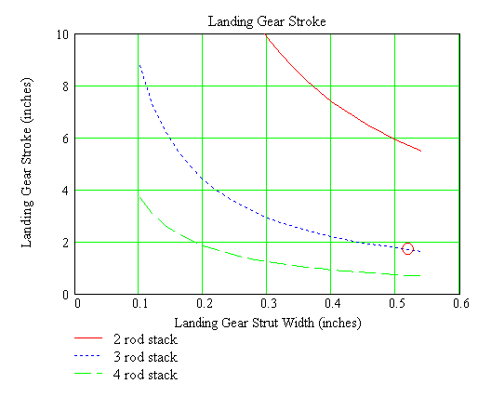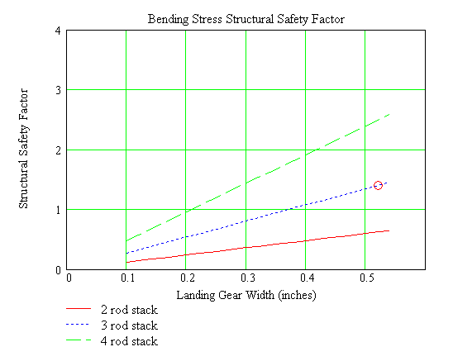
Figure 4.3: Analytical Results

4.2 Component & Total Weight Summary

The weight of each of the principal aircraft components was estimated in a Mathcad parametric model; the resulting values are included in Table 4.1, below. These data were obtained using a combination of published as well as experimentally-determined weights and densities; for cases in which the densities were known, the analysis requires estimations of the volume or area of various components. Notably, the analytical estimates were deliberately conservative, hence the resulting weight values were sometimes larger than those found on the final production craft.

Component | Weight | Local Cg's | Local Cg's
 | (lb) | (in. from firewall) | (in. from mac)
Engine/Fwd
Engine & Prop | 1.55 | -1.15 | -24.525
Fuel Tank (Half Full) | 0.3 | 3.25 | -20.125
Batteries | 0.25 | 4.75 | -18.625
Receiver | 0.25 | 5.28 | -18.095
Controls
Aileron Servos (2) | 0.551 | 36.4 | 13.025
Vtail Servo | 0.276 | 70.37 | 46.995
Htail Servo | 0.276 | 79.38 | 56.005
Nose Gear Servo | 0.276 | 0 | -23.375
General
Fuselage | 1.679 | 28.17 | 4.795
Top Wing | 1.227 | 17.79 | -5.585
Bottom Wing | 1.275 | 34.09 | 10.715
Winglet (side) (2) | 0.766 | 30.58 | 7.205
Horizontal Tail | 0.428 | 72.47 | 49.095
Vertical Tail | 0.342 | 65.79 | 42.415
Front Gear | 0.259 | 0 | -23.375
Main Landing Gear | 0.517 | 26.5 | 3.125
Empty Total | 10.222 | 26.125 | 2.75
Payload
Payload | 22 | 22.125 | -1.25
Design Total | 32.222 | 22 | -1.375
Table 4.1: Weight and Balance Data
4.3 Local and Global Center of Gravity Summary
Also shown in the preceding table are the local centers of gravity for each component, in terms of the distance (in inches) from the aerodynamic center. These values were calculated using a Mathcad parametric model as well as a three-dimensional representation in SolidWorks. By summing the weight and balance contributions of each component, as arranged appropriately, the analysis provided a global center of gravity location for the aircraft. During the design refinement phase, this analysis was used to properly distribute the components, in order to produce an acceptable center of gravity for longitudinal stability. As seen in Table 4.1, the global center of gravity in the loaded final design was 1.25 inches forward of the aerodynamic center.
5.0 PROPULSION

Per the competition requirements, the engine specified for this aircraft was the O.S.61 FX, with an E-4010 muffler, and no gearing was used between the crankshaft and the propeller. Due to these restrictions, the only available method of optimizing the propulsion performance was to select the appropriate propeller to deliver maximum thrust with the specified engine. To this end, the engine performance was characterized by static testing, using a torque stand and a thrust stand. The test results were used to determine the engine torque, power, and available thrust, as shown in Figures 5.1 & 5.2.
By observing the trends in the data collected both this year and in prior years (see Figure 5.2) it was evident that a slightly longer and slightly lower pitch propeller could provide more thrust. A carbon fiber reinforced plastic 14.5x4 propeller was tested and found to consistently deliver a 10% increase in thrust when compared to the nylon 14x5n propeller that has frequently been used in past years. Using the thrust and power data, a propulsion system model was developed in Mathcad to extrapolate the thrust at speed and power at speed curves (shown in Figure 5.3), which were necessary for predicting the aircraft performance.
Figure 5.1: Engine Performance Data for (A) Torque and (B) Power, versus RPM
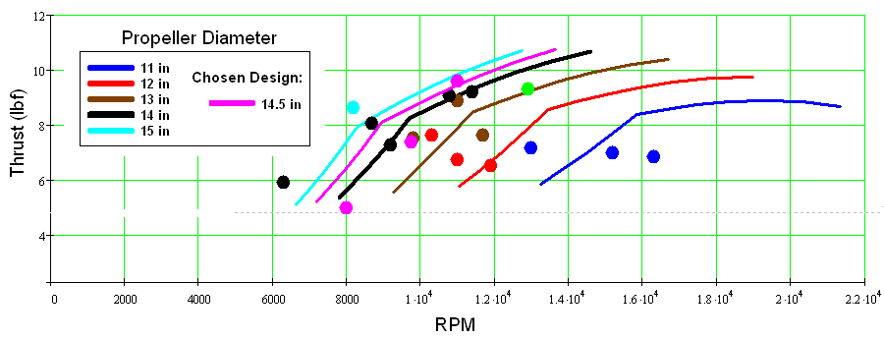
Figure 5.2: Thrust Curves & Test Data Points for Various Propellers

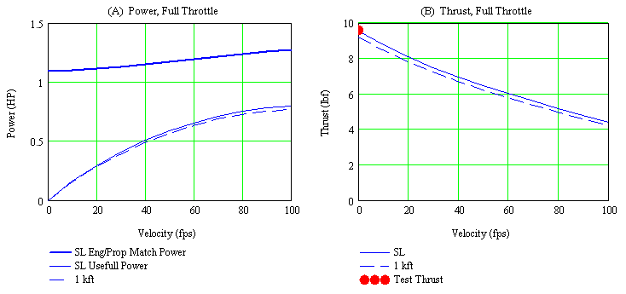
Figure 5.3: (A) Power vs. Velocity (B) Thrust vs. Velocity

6.0 Stability & Controls
The goal of the stability and controls group was to determine the aircraft’s flight stability characteristics, and to then construct a control system that enables the aircraft to perform the necessary mission. The total mission profile calls for low speed, low altitude flight, with minimal but essential maneuvering of the aircraft. Very few mission characteristics impose constraints on the control system; therefore flight stability during take-off and landing was considered critical to the control system design.

6.1 Flight Stability
The aircraft’s flight stability analysis was broken up into two parts: static and dynamic stability. Starting off with static stability, the pitch axis is the most important axis under consideration. The elevator size was selected based upon common aircraft configurations – an elevator chord fraction of 0.4 and an elevator span fraction of 1.0 were selected. The aircraft static pitching moment balances were calculated for various flight conditions. Figure 6.1 shows the moment coefficient (C_{m}) as a function of AOA for the design CG, and ± 1.0 inch from the design CG. The neutral point is located approximately 2.5 inches behind the design CG. Figure 6.2 shows the C_{m} as a function of AOA for three elevator deflections: 0º, and ± 5º.
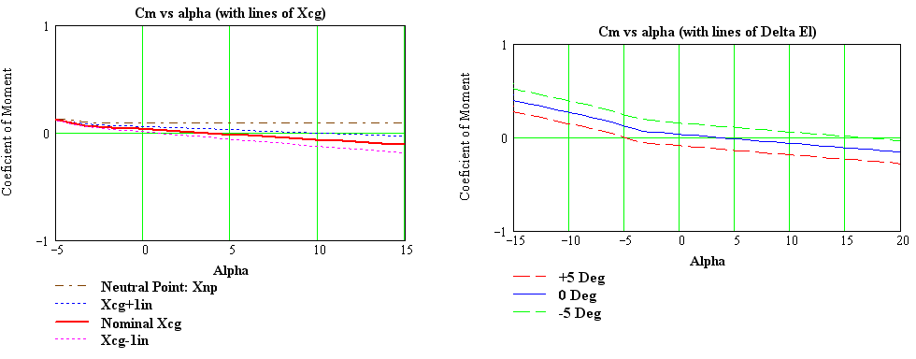
Figure 6.1: Neutral Point and Center of Gravity Figure 6.2: Elevator Deflection

Yaw axis stability is primarily a function of the vertical aerodynamic surface area. Due to the side forces created by the winglets, a relatively large vertical tail volume coefficient was needed. The rudder size was selected based upon common aircraft configurations. A rudder chord fraction of 0.4 of the root chord and a rudder span fraction of 1.0 were selected. Table 6.1 lists the pitch and yaw derivatives calculated for the aircraft’s configuration.
The main contributor to roll axis static stability is the box wing configuration, specifically the distance between the center of gravity and the mean aerodynamic center. To account for a box wing configuration, the aileron sizes were adjusted to be slightly larger than those found on common aircraft. An aileron chord fraction of 0.305 and an aileron span fraction of 0.48 were selected. The ailerons are only installed on the bottom wing, which is closer to the thrust line, so that ailerons located there allow for slightly better axial rolls.
Lateral flying qualities were the focus of the dynamic stability analysis, due to concern about the side forces created by the box wing configuration. Lateral approximations were used to evaluate the roll, spiral, and Dutch roll responses of the aircraft. Table 6.2 displays the lateral approximation eigenvalues, which suggest that the airplane has stable roll and spiral modes, although one unstable Dutch roll pole was encountered. This pole makes the Dutch roll mode unstable, however the aileron sizes have been adjusted to counteract the Dutch roll effect by improving the control of the aircraft.
Cm_{α} | Cm_{q} | Cm_{δe} | Cn_{β} | Cn_{δr} |  | Dutch roll |  | Roll | Spiral
-.195 | -15.32 | -1.392 | .642 | -.304 |  | 6.85 | -8.91 | -14.7 | -.176
Table 6.1: Pitch and Yaw Derivatives Table 6.2: Lateral Eigenvalues

6.2 Control System
The radio control (RC) system is built around a Futaba 9CAP controller and receiver unit. Separate servos were chosen for the left and right ailerons to eliminate long control linkages. The large size of the aircraft configuration and limited space for transportation to the flight-line required the wings of the aircraft to be removed and stored parallel to the fuselage. Due to the separate segments, a control and linkage system design was needed to limit the fieldwork necessary to assemble the aircraft for flight. The left and right halves of the wing contain the servos for their respective ailerons. Similarly, the vertical and horizontal tail sections contain the rudder and elevator servos. In order to have the most robust and rigid control linkage possible, the four main control surfaces (left and right ailerons, elevators and rudder) are connected to their respective servos using “horn” linkages and short, rigid push-rods. This arrangement is typically found on aileron linkages for smaller RC aircraft. The forward fuselage contains the receiver, the battery pack, the nose gear servo, and the engine throttle servo. The nose wheel and throttle are controlled using flexible rod linkages. Significantly, the torque rating for these servos was far above the moment required for control surface deflection.

7.0 TELEMETRY & WIND-TUNNEL TESTING
An additional element of the design process was introduced this year, namely an effort to provide real-time telemetry data. In particular, the following parameters were of interest: angle of attack, airspeed, and the pilot control input history. Furthermore, the intent of the design team was to record such data, to be used for post-flight performance reviews. A differential pressure sensor was installed in the upper wing, which provided the means to calculate the angle of attack (AoA); this sensor was evaluated and calibrated by experimental simulation in a low-speed wind tunnel facility.
The AoA sensor package consists of a Silicon Microstructures SM5852-001 differential pressure sensor, which measures 0-0.15 psi differential pressure. The sensor is mounted inside the wing, with pressure taps above and below the wing, at the quarter-chord point. The pressure ports are mounted flush with the surfaces are sealed to the pressure sensor to ensure accuracy. The sensor’s measurements will be sent to an Eagle Tree System’s Flight Data Recorder (FDR) Version 2 in an analog DC signal, where it will be converted to a digital signal and transmitted real-time to the ground crew using the telemetry system. The FDR will also log and transmit the following, in real-time: altitude, airspeed, servo jitters, control inputs, battery pack voltage, atmospheric temperature and engine RPM.
The pressure sensor and airfoil section were tested in a low-speed, 2ft-by-2ft cross-section, recirculating wind tunnel in the Gas Dynamics & Propulsion Laboratory, at the University of Cincinnati. Differential pressure was measured, for a series of AoA values and wind tunnel velocities. In Figure 7.1, the experimental results are displayed for 6 different airspeeds, labeled by the corresponding Reynolds numbers. For comparison, the published values for the airfoil² are also shown therein, as continuous lines. Most significantly, the experimental data were in close agreement with the published values, which assures that the construction and implementation of the airfoil were in agreement with the theoretical analysis.

Reference (2): Selig et al, “Summary of Low-Speed Airfoil Data,” Vol. 2. Obtained from the University of Illinois, Urbana-Champagne website.
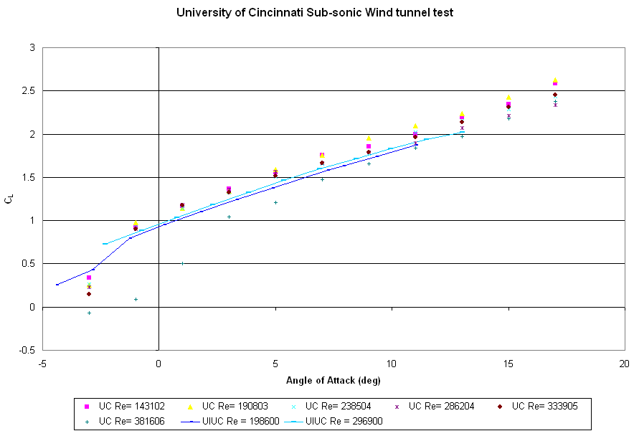
Figure 7.1: Data Correlation from UC Wind Tunnel Testing

8.0 PERFORMANCE & OPTIMIZATION

Finally, by incorporating the results from each of the previous analyses, the performance of the design was evaluated and adjusted, in order to satisfy the flight requirements. Of particular concern, for the prescribed mission, were the design weight (especially the payload weight) and the ground roll length required to reach takeoff. Additionally, a minimum climb rate was stipulated. Through an iterative process, a series of Mathcad models were employed to study the influence of main chord length upon the feasible design weight. Lastly, the performance of the final design was determined.
8.1 Trade Study
A simple trade study was conducted to optimize the design weight and main wing chord length. To be conservative, the design limit set upon ground-roll distance was 190 ft. Based upon preliminary assumptions, a range of chord lengths from 1 ft to 2 ft were investigated. Within this range, the permissible total weight of the design was determined, using the ground-roll limitation of 190 ft as the discriminating factor; the results are shown in Figure 8.1. Predictably, the design weight increased as the chord length increased. Concurrently, the climb rate corresponding to each design point was determined, which provided a limitation upon the viable chord length. To reach the required climb rate of 200 ft/min at liftoff, the maximum chord length was approximately 1.5 ft. Therefore, the selected configuration included a 1.5 ft main wing chord, which permitted a total design weight of 32 lbs.
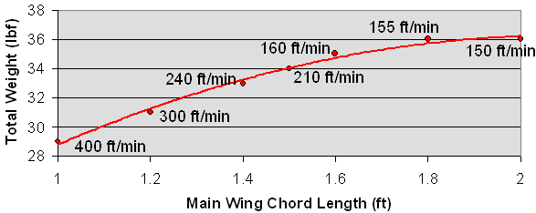
Figure 8.1: Design Weight vs. Wing Chord Length

8.2 Aircraft Performance
After determining the final configuration, estimates of the aircraft performance were readily available from the aforementioned parametric models. A brief summary of the key results follows immediately below. Note that in Figures 8.2 and 8.3, curves for two alternate design weights are provided for comparison, whereas Figures 8.4 and 8.5 represent only the final design behavior.
First, Figure 8.2 illustrates the increase in ground-roll distance (essentially, the movement of the aircraft down the runway) as the velocity increases. Most importantly, the lift-off velocity of 39.3 ft/sec is reached well within the ground-roll limit. Next, the V-N diagram (Figure 8.3) indicates a maximum wing loading of 3 g’s, which occurs only at velocities above about 57 ft/sec.
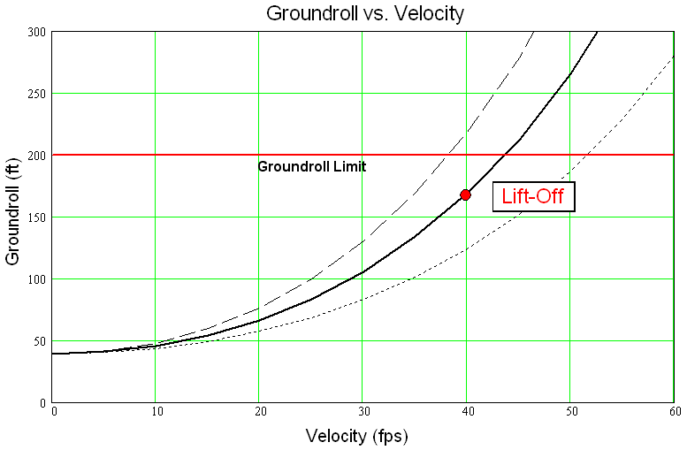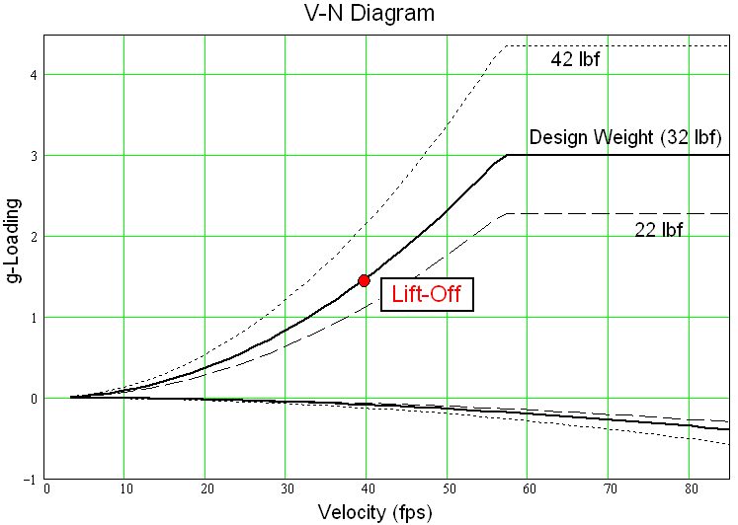
Figure 8.2: Ground-roll vs. Velocity Figure 8.3: V-N Diagram

Lastly, the angle and rate of climb are also plotted as functions of velocity (Figures 8.4 & 8.5). In both cases, the values are zero at low velocities, during the takeoff run. Upon reaching the lift-off velocity (39.3 ft/sec), the aircraft leaves the runway with a climb angle of roughly 3 degrees and a climb rate of 210 ft/min. Thereafter, the climb angle increases to a maximum of roughly 4.5 degrees, at the optimum climb condition. The corresponding maximum climb rate is around 400 ft/min, for velocities between 60 to 70 ft/sec. The actual operation of the aircraft may not reach these performance conditions, but the analysis indicates that the aircraft will provide acceptable takeoff and climb performance for competition purposes.
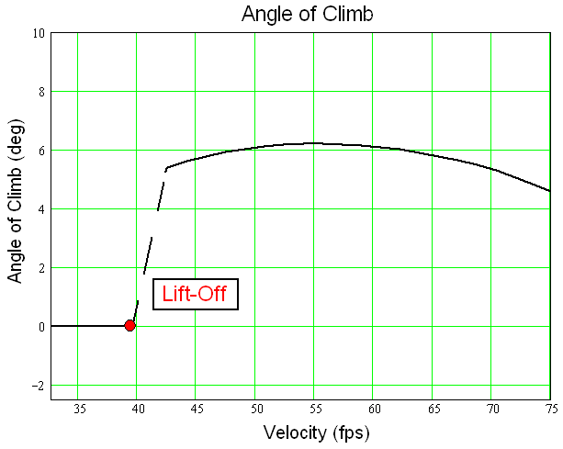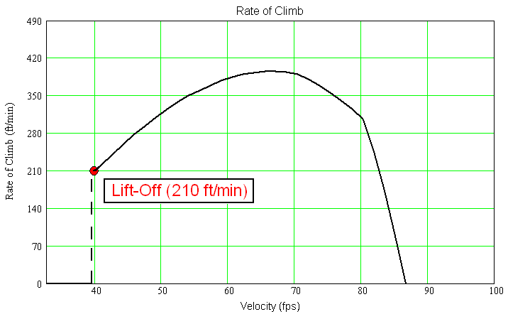
Figure 8.4: Climb Angle vs. Velocity Figure 8.5: Rate of Climb vs. Velocity

